

Economics

SAC 3.1 UNIT 3 OUTCOME 3

You will have 45 minutes to complete this task plus 5 minutes reading time

Teacher: Mr. Daniel Charles

The total SAC contributes to 25/100 of SAC marks allocated for Unit 3.

Allowed materials for this task include:
- Pens, calculator, pencils, rulers, erasers, highlighters

Name ____________________________________________

Note: The grade or score for this task is only part of the internal assessment for this Unit. Your total School-assessed Coursework score may change as a result of statistical moderation by VCAA.

Grade/Score: ______ Satisfactory Completion? S/N: ______
(Provisional)

Section A – multiple choice questions

Question 1

If Australia see a decrease in their international credit rating, this would lead to

A. a decrease in the supply of the AUD and a deprecation
B. an increase in the supply of the AUD and a deprecation
C. an increase in the supply of the AUD and an appreciation
D. a decrease in the supply of the AUD and an appreciation

Question 2
If Australia’s foreign equity assets exceed its foreign equity liabilities, this means that

A. Australia has invested less overseas than foreigners have invested in Australia.
B. Australia has invested more overseas than foreigners have invested in Australia.
C. the Australian Government has increased its borrowings from overseas to fund budget deficits.
D. the Australian Government has decreased its borrowings from overseas to fund budget deficits

Question 3
An improvement in Australia’s current account balance is most likely to occur when

A. the trade balance surplus increases.
B. the terms of trade deteriorate.
C. the Australian dollar appreciates.
D. China’s economic growth slows.

Question 4
The payment of dividends to overseas shareholders will appear in the balance of payments as a

A. credit in the capital and financial account.
B. debit in the capital and financial account.
C. credit in the balance of payments on current account.
D. debit in the balance of payments on current account.

Question 5

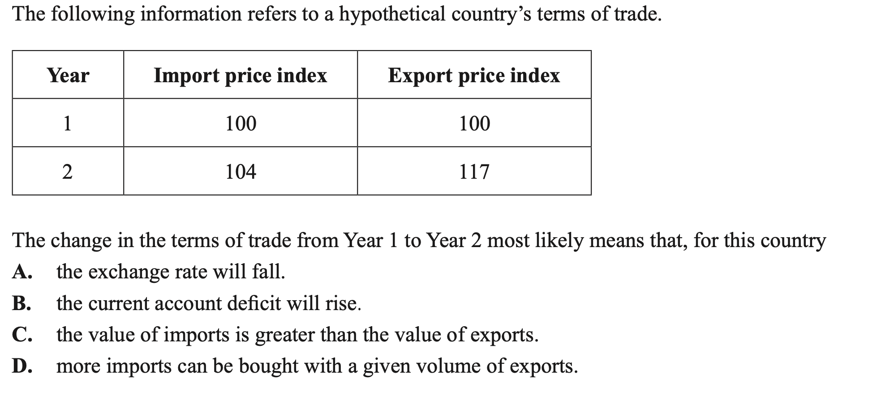

Section B – Structured questions

Question 1 (8 marks)

a. The Australian economy has had a current account surplus since 2019. Outline once factor that has led to this surplus.
2 marks
________________________________________________________________________________________________________________________________________________________________________________________________________________________________________________________________________________________________________________________________________________________________________________________________________________________________________________________________________________________________________________________________________________________________________________________________________________________________________________________________________________

b. Describe the influence that the current account surplus would have on the value of the exchange rate, ceteris paribus.
2 marks
________________________________________________________________________________________________________________________________________________________________________________________________________________________________________________________________________________________________________________________________________________________________________________________________________________________________________________________________________________________________________________________________________________________________________________________________________________________________________________________________________________
c. Before 2019, the Australian economy had a current account deficit since 1975. Explain one structural cause of the persistent current account deficit.
2 marks
________________________________________________________________________________________________________________________________________________________________________________________________________________________________________________________________________________________________________________________________________________________________________________________________________________________________________________________________________________________________________________________________________________________________________________________________________________________________________________________________________________

d. Explain the impact that an increase in net foreign debt would have on the current account balance.
2 marks
________________________________________________________________________________________________________________________________________________________________________________________________________________________________________________________________________________________________________________________________________________________________________________________________________________________________________________________________________________________________________________________________________________________________________________________________________________________________________________________________________________

Question 2 (6 marks)
a. Explain the impact that the trend in the terms of trade over the last two years would have on the value of the exchange rate, and the goal of full employment.
4 marks

Exchange rate
________________________________________________________________________________________________________________________________________________________________________________________________________________________________________________________________________________________________________________________________________________________________________________________________________________________________________________________________________________________________________________________________________________________________________________________________________________________________________________________________________________

Goal of full employment
________________________________________________________________________________________________________________________________________________________________________________________________________________________________________________________________________________________________________________________________________________________________________________________________________________________________________________________________________________________________________________________________________________________________________________________________________________________________________________________________________________

b. Outline one possible cause for the trend in the terms of trade over the last two years.
2 marks
________________________________________________________________________________________________________________________________________________________________________________________________________________________________________________________________________________________________________________________________________________________________________________________________________________________________________________________________________________________________________________________________________________________________________________________________________________________________________________________________________________

Question 3 (7 marks)
a. Explain how the following factors might influence the value of the exchange rate, ceteris paribus:
3 marks

Currency speculation
________________________________________________________________________________________________________________________________________________________________________________________________________________________________________________________________________________________________________________________________________

A change in relative interest rates
________________________________________________________________________________________________________________________________________________________________________________________________________________________________________________________________________________________________________________________________________

An increase in import spending
________________________________________________________________________________________________________________________________________________________________________________________________________________________________________________________________________________________________________________________________________

b. The current inflation rate in Australia is 7%, well above the goal of low inflation. Analyse how a movement in the exchange rate would reduce inflationary pressures in the Australian economy.
4 marks
________________________________________________________________________________________________________________________________________________________________________________________________________________________________________________________________________________________________________________________________________________________________________________________________________________________________________________________________________________________________________________________________________________________________________________________________________________________________________________________________________________________________________________________________________________________________________________________________________________________________________________________________________________________________________________________________________________________________________________________________________________________________________________________________________________________________________________________________________________________________________________________________________________________________________________________________________________________________________________________________________________________________

Question 4 (4 marks)
a. Identify and explain two factors that you improve Australia’s international competitiveness and describe how this would impact the current account balance.
4 marks
________________________________________________________________________________________________________________________________________________________________________________________________________________________________________________________________________________________________________________________________________________________________________________________________________________________________________________________________________________________________________________________________________________________________________________________________________________________________________________________________________________________________________________________________________________________________________________________________________________________________________________________________________________________________________________________________________________________________________________________________________________________________________________________________________________________________________________________________________________________________________________________________________________________________________________________________________________________________________________________________________________________________

EXTRA WRITING SPACE
________________________________________________________________________________________________________________________________________________________________________________________________________________________________________________________________________________________________________________________________________________________________________________________________________________________________________________________________________________________________________________________________________________________________________________________________________________________________________________________________________________________________________________________________________________________________________________________________________________________________________________________________________________________________________________________________________________________________________________________________________________________________________________________________________________________________________________________________________________________________________________________________________________________________________________________________________________________________________________________________________________________________________________________________________________________________________________________________________________________________________________________________________________________________________________________________________________________________________________________________________________________________________________________________________________________________________________________________________________________________________________________________________________________________________________________________________________________________________________________________________________________________________________________________________________________________________________________________________________________________________________________________________________________________________________________________________________________________________________________________________________________________________________________________________________________________________________________________________________________________________________________________________________________________________________________________________________________________________________________________________________________________________________________________________________________________________________________________________________________________________________________________________________________________________________________________________________________________________________________________________________________________________________________________________________________________________________________________________________________________________________________________________________________________________________________________________________________________________________________________________________________________________________________________________________________________________________________________________________________________________________________________________________________________________________________________________________________________________________________________________________________________________________________________________________________________________________________________________________________________________________________________________________________________________________________________________________________________________________________________________________________________________________________________________________________________________________________________________________________________________________________________________________________________________________________________________________________________________________________________________________________________________________________________________________________________________

